**CIS 481 – Intro to Information Security**

**IN-CLASS EXERCISE # 10**

Names of team members: **Trisia Baltazar, Adrian Boone, Savanah Kennedy, Ryan Smith**

Logistics

A. Get into your regular team

B. Discuss and complete the assignment together. Don’t just assign different problems to each teammate! That defeats the purpose of team-based learning.

C. Choose a recorder to prepare the final copy to submit to instructor in Blackboard.

**Problem 1**

Name and describe the four basic conversion strategies discussed in the text that may be used when converting to a new system. Under which circumstances would each be considered the right approach? (10 pts.)

* Direct changeover - This conversion strategy is stopping the old system and starting the new one without overlap. A drawback is that if the new system fails or needs modification, users may be without services as repairs occur. This would be considered the right approach when every employee should start using stronger passwords on a certain date or the entire company changing procedures to accommodate the installation of a new firewall.
* Parallel operations - This conversion strategy is running the new system concurrently with the old system. This approach can reinforce an organization’s information security by allowing the old system(s) to serve as backup for the new system. Drawbacks involve maintaining and dealing with both systems and sets of procedures. If you want to run two firewalls concurrently, this conversion strategy would be the right approach.
* Phased implementation - This conversion strategy involves a measured rollout of the planned system. A part of the system is brought out and disseminated across an organization before the next piece is implemented. This is the best approach to security project implementation. If a company wanted to update both VPN and IDPS systems it might introduce the VPN solution first so employees can get used to that. Every week another department would be allowed to use the VPN until all departments use it. Once the VPN has been phased in, the company can start working on revisions to the IDPS.
* Pilot Implementation - This conversion strategy is implementing the entire system into a single office, department, or division, and dealing with issues that arise before expanding the system to the rest of the organization. This approach is preferred when an isolated group can serve as the “guinea pig.” Problems with new systems will not affect the organization as a whole that way. What a research and development group does would not affect the security of the entire organization.

**Problem 2**

Complete Exercise 1 from p. 576 of the text. Model your WBS on Table 10-1 from p. 541 of the text. Assume that work on the project may begin as early as next Monday. (15 pts.)

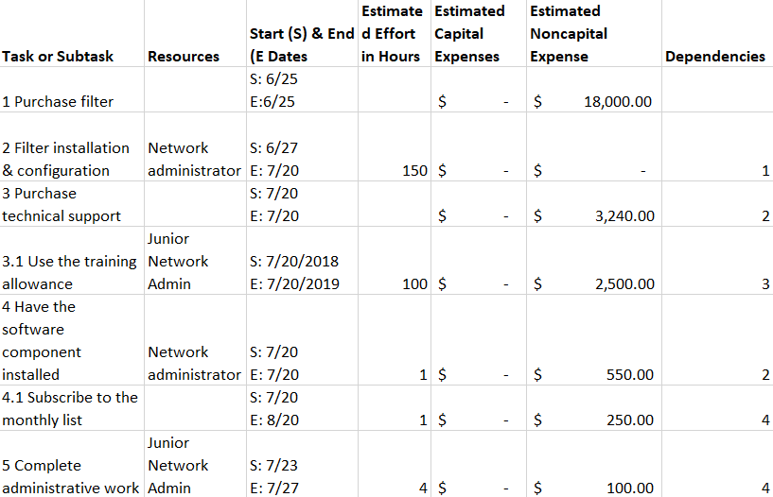

This project is going to heavily rely on the network administrator. Most of the work is going to be in setting up the filter itself. This is going to require in depth knowledge of the company network and networks in general. Installing the software component of the filter should not require much technical knowledge. The junior network administrator will be responsible for maintaining and supporting the filter. Through the training they receive from the training allowance they will be able to complete the necessary weekly administrative work.